**SUPPLEMENTARY ONLINE MATERIALS: Foraging, fear and behavioural variation, a lesson from hummingbirds**

To analyse the effect of passing time (i.e. habituation, satiation) on the foraging efficency, we examined available time series of foraging efficiency with two approaches. Firstly, we considered a linear mixed model (*lmer* function in *lmerTEST* package, Kuzetsowa et al 2017) with foraging efficiency as a response variable and the sequence of consecutive visits during the control phases as an explanatory (linear for simplicity) response. Birds indentity was also included in the model as a random factor. The model output indicated on significant and positive effect of the visit on the foraging efficiency (glmm, estimate 0.006 ± SE 0.002, t = 1.47, df = 135.3, P = 0.03; Fig S1).

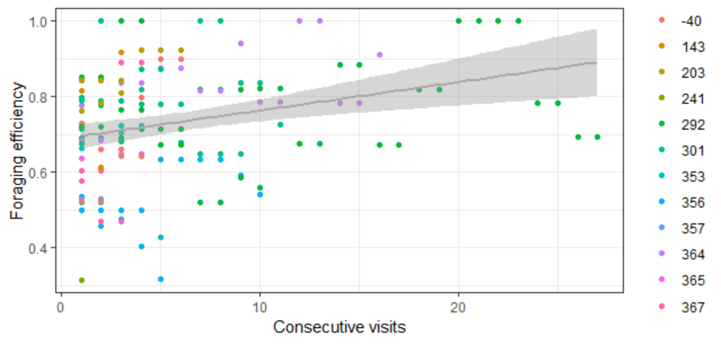

**Figure S1** Relationship between foraging efficiency and consecutive visits at feeders area during the control phases of the experiment (all individuals considered).

In the second approach we used data of six time series from four different individuals that were the most frequent visitors at the feeder during control phases (≥ 5 records of consecutive visits during the control phases). We did not find any evidence of the autocorrelation in the examined set, i.e. correlation coeficients for all the lags were statistically insignificant for all the examined time series (Fig. S2).

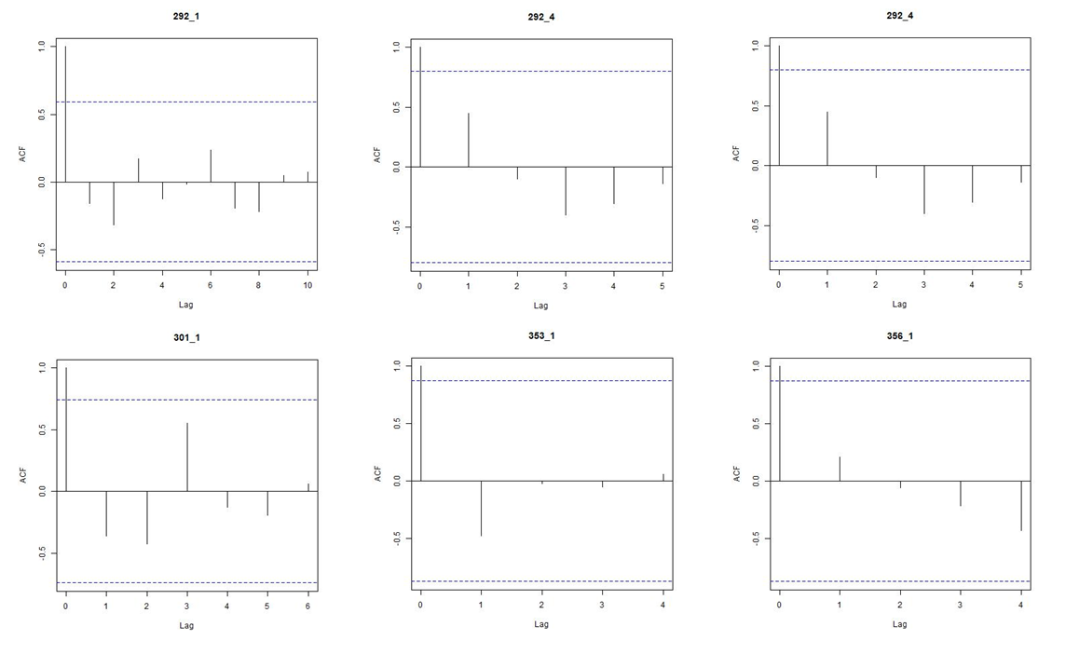

**Figure S2** Autocorrelation analysis plots for six time series (four individuals) of foraging efficiency during consecutive visits at feeders area during the control phases of the experiment. The titles denote individual identity and number of control session. Solid vertical lines denote correlation coefficient for particular lag of the time series, and dashed horizontal lines delimit the range of their significance.

Considering both applied approaches it seems that foraging efficency at feeders may improve over the time indicating habituation, although it apparently happens only after a considerable number of visits of an individual. Given that we had only one individual being such a frequent user of the feeders place, we treated all the birds visits as time-independent data points. Besides, given the fact that experiments with bullet ants were always performed after the control phases, a negative effect of the experimental treamtent could be only mitigated. If that did not happen, the results of the experiment are apparently solid.

**Results on single predictor models**

To examine foraging efficiency (response variable) in regard to the context, behavioural traits and their all interactions (predictors) we applied Bayesian MCMC generalized linear modelling, with bird’s identity included as a random factor. We performed the analyses in two approaches. In the first one, we run analysis for each behavioural parameter separately (“single behaviour-predictor models”). In the second approach, all the behaviour-predictors were considered in a single, global model. The two approaches yield qualitatively similar results (Fig. S3), therefore we presented the latter in the main text, and below we present the outcome of the single behaviour-predictor models.

**Model selection results**

**Table S1** Ranking of models explaining foraging efficiency of Long-billed Hermits, ordered by delta Deviance Information Criterion (DIC; Akaike’s Information Criterion AIC yields to same conclusions). Best model for each parameters is bolded.

|  |  |  |  |  |  |  |  |  |
| --- | --- | --- | --- | --- | --- | --- | --- | --- |
| **Response** | **Predictors** | **df** | **DIC** | Δ **DIC** | **weight DIC** | **AIC** | Δ **AIC** | **weight AIC** |
| **arousal** | **Context interaction** | **6** | **-365.8347** | **0.00** | **1.00** | **-365.8307** | **0.00** | **1.00** |
| arousal | Parameter | 4 | -328.9776 | 36.86 | 0.00 | -331.0490 | 34.78 | 0.00 |
| arousal | Context | 4 | -309.6083 | 56.23 | 0.00 | -312.2369 | 53.59 | 0.00 |
| arousal | Null | 3 | -298.5859 | 67.25 | 0.00 | -302.1584 | 63.67 | 0.00 |
| **exploration** | **Context interaction** | **6** | **-348.0369** | **0.00** | **1.00** | **-348.9852** | **0.00** | **1.00** |
| exploration | Context | 4 | -310.8631 | 37.17 | 0.00 | -313.1746 | 35.81 | 0.00 |
| exploration | Parameter | 4 | -307.5661 | 40.47 | 0.00 | -310.6167 | 38.37 | 0.00 |
| exploration | Null | 3 | -298.6007 | 49.44 | 0.00 | -302.1654 | 46.82 | 0.00 |
| **risk_avoidance** | **Parameter** | **4** | **-314.1987** | **0.00** | **0.53** | **-316.4061** | **0.00** | **0.72** |
| risk_avoidance | Context interaction | 6 | -313.7740 | 0.42 | 0.43 | -314.0783 | 2.33 | 0.23 |
| risk_avoidance | Context | 4 | -308.9691 | 5.23 | 0.04 | -311.0324 | 5.37 | 0.05 |
| risk_avoidance | Null | 3 | -296.4492 | 17.75 | 0.00 | -299.8973 | 16.51 | 0.00 |

**Interpretation:** All best models contained an interaction with a behaviour parameter. All models with interaction provided a better fit than the context (low vs high risk) models; effect sizes for the models with interaction terms presented in Table S2.

**Table S2** Effects of behavioural variables and predation context on foraging efficiency of long-billed hermits. Effects are model slope estimates derived from Bayesian MCMC generalized linear model. Only models that improved fit compared to the null models are presented.

|  |  |  |  |  |  |  |  |  |  |
| --- | --- | --- | --- | --- | --- | --- | --- | --- | --- |
| **Response** | **Parameter** | **Predictor** | **Effect size** | **CI 2.5%** | **CI 97.5%** | **pMCMC** | **intercept** | **N indv** | **N obs** |
| foraging effiency | arousal | contextHigh risk | -0.0352 | **-0.0668** | **-0.0021** | 0.0347 | 0.5343 | 12 | 193 |
| foraging effiency | arousal | arousal | 0.0663 | **0.0195** | **0.1072** | 0.0044 | 0.5343 | 12 | 193 |
| foraging effiency | arousal | contextHigh risk:arousal | 0.2815 | **0.1853** | **0.3802** | 0.0001 | 0.5343 | 12 | 193 |
| foraging effiency | exploration | contextHigh risk | -0.0645 | **-0.0972** | **-0.0316** | 0.0002 | 0.5346 | 12 | 193 |
| foraging effiency | exploration | exploration | 0.3039 | **0.034** | **0.5697** | 0.0296 | 0.5346 | 12 | 193 |
| foraging effiency | exploration | contextHigh risk:exploration | -1.1133 | **-1.4827** | **-0.7451** | 0.0001 | 0.5346 | 12 | 193 |
| foraging effiency | risk_avoidance | risk_avoidance | -0.0648 | **-0.0924** | **-0.0377** | 0.0001 | 0.5209 | 11 | 192 |

**Supplementary figures:**



**Figure S3** Distribution of foraging efficiency and behavioural parameters in the study population of the long-billed hermits, raw (A) and log-transformed (B) data.

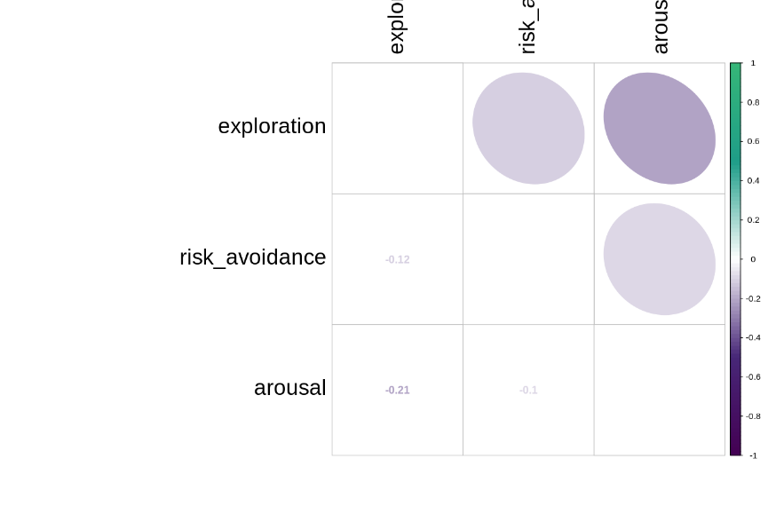

**Figure S4.** Correlation coeficients between the three behavioural variables.

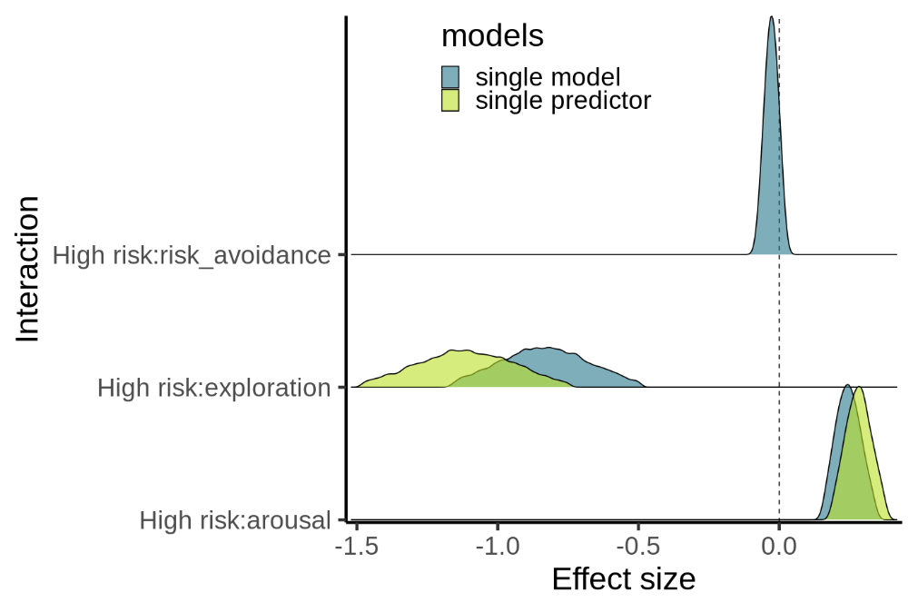

**Figure S5** Comparison ofestimates from single predictor models and the global model.

**Literature cited:**

Kuznetsova A, Brockhoff PB, Christensen RHB (2017). “lmerTest Package: Tests in Linear Mixed Effects Models.” Journal of Statistical Software, **82**(13), 1–26. doi: [10.18637/jss.v082.i13](https://doi.org/10.18637/jss.v082.i13)